20.06.2011

To all Media

Chamika And Sachini wins Chess Nationals 2011

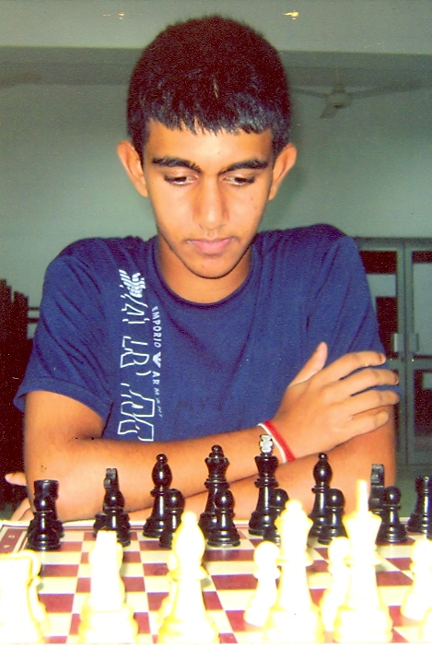
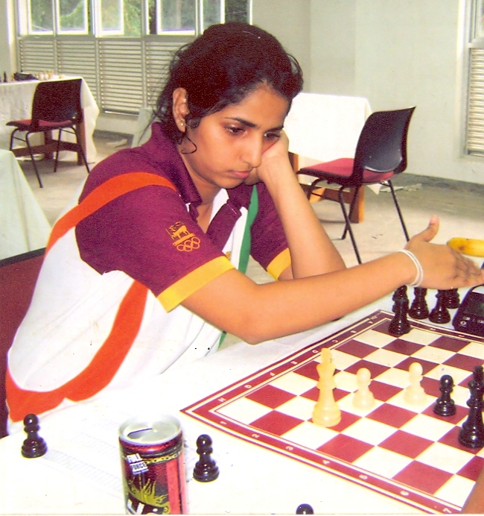

Chamika Perera (WIM) Sachini Ranasinghe
Chamika Perara, a 16 year old student of Trinity College became the Sri Lanka National Chess Champion convincingly. Young Chamika played the event very confidently and scored a total of 9 1/2 points out of possible 13 games to achieve this title. It was a one sided race for Sachini Ranasinghe (Musaeus College), the maiden women International Master of Sri Lanka in the Women's Nationals. She scored a total of 12 points out of possible 13, just giving away couple of draws throughout the event.

The Sri Lanka National Chess Championships conducted by the Chess Federation of Sri Lanka with the support of the Ministry of Sports was held from 17th to 26th of September 2011 at the University of Moratuwa. A total of Rs. 168,000/= was offered by for the winners in this 13 round Round Robin Tournaments.
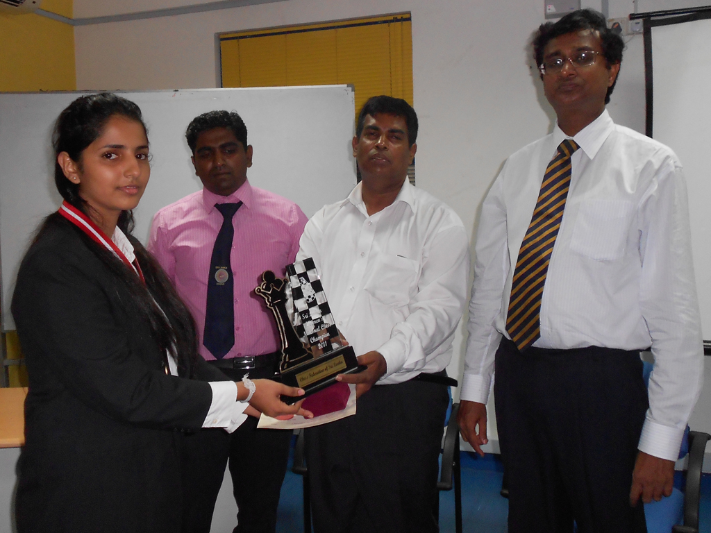
From L-R: Miss Sachini Ranasinghe, Mr. Jagath Ketalawala (Hony. Secretary,CFSL) By Mr. Luxman Wijesuriya (President, Zone
3.2, FIDE, General Secretary, Commonwealth Chess Association), Mr. Upali Gunasekera (President, CFSL & Principal, Royal College)

Chamika who represented the Country at the Chess Olympiad in Khanty Mansiysk last year is performing well during the year. He earned Rs. 30,000/- cash award with the National Chess Championship Trophy. GC Anuruddha of Sri Lanka Navy had to satisfy with the 2nd place with 9 points to get the Silver medal with Rs. 20,000/- in Cash while Prasanna Kurukulasuriya, also from Sri Lanka Navy was 3rd with 8 1/2 points and recieved Rs. 10,000/- in cash with the Bronze medal. Rajeendra Kalugampitiya (University of Peradeniya) was 4th with 8 points and AMCB Alahakoon(University of Moratuwa) was 5th with 8 points.

WIM Sachini Rajnasinghe was also in the National Team for the last year Chess Olympiad and she won the Asian Zone 3.2 in last March in Sri Lanka to earn the Women International Master Title with a seat in the next World Championships to be held in Khanty Mansiysk, Russia in 2012. Sachini was awarded the Women's National Championship Trophy, Gold Medal and Rs. 20,000/- in cash. Dinushki Premanath (Girls High School ) was 2nd with 11 points and recieved Rs. 12,000/- in cash with the Silver medal while Naduni Abeywardena (Furgusion High School) was 3rd with 8 points. Tiumi Yashora (Visakha Vidyalaya) and Thilini Koswatte (University of Peradeniya) scored 7 1/2 points each and placed 4th and 5th respectively on the tie breaker.

Standings Nationals: Chamika Perera (Trinity College) 9.5, GC Anuruddha (Sri Lanka Navy) 9, Prasanna Kurukulasuriya(Sri Lanka Navy) 8.5, RS Kalugampitiya(University of Peradeniya) 8, AMCB Alahakoon(University of Moratuwa) 7.5, Chandana Wijekoon(Sri Lanka Navy) & Yasas Lamawansa (Trinity College) 7, Romesh Weerawardena (Paul Morphy Chess Club), PKUM Jayasundara (Nalanda College) & WSVK Koggala(University of Moratuwa) 6, Wiman Bhagya (Nf3 Chess Club) & RS Dissanayake (Blue and Gold Chess Club) 5, Gihan De Silva (Reborn Chess Club) 4 and PD Senanayake (Fisher CC) 2.5.

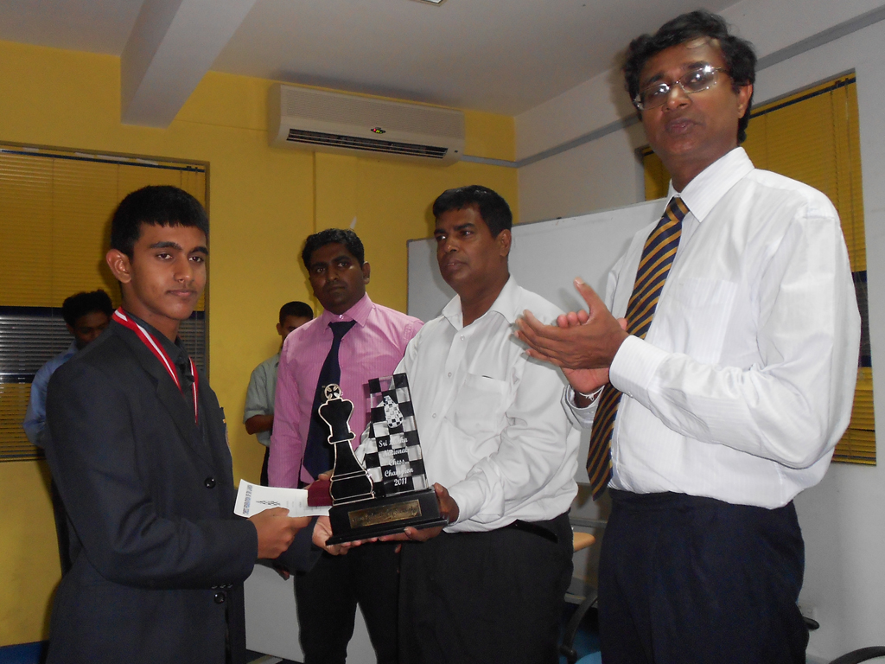
From L-R: Miss Chamika Perera, Mr. Jagath Ketalawala (Hony. Secretary,CFSL) By Mr. Luxman Wijesuriya (President, Zone
3.2, FIDE, General Secretary, Commonwealth Chess Association), Mr. Upali Gunasekera (President, CFSL & Principal, Royal College)
Standings Women's Nationals: WIM Sachini Ranasinghe (Musaeus College) 12, WEN Dinushki Premanarth (Girls High School) 11, Naduni Abeywardena(Furguson High School) 8, Tiumi Yashora (Visakha Vidyalaya) & Thilini Koswatte(University of Peradeniya) 7, WFM Pramodya Senanayake(University of Moratuwa) & Panchali Perera(Musaeus College) 6.5, UGY Methmali(University of Sri Jayawardenapura) 6, SAK Chandrasiri (Girls High School), WFM Supeshala Thilakawardena (Musaeus College) & Pramodhi Sathya (Maliyadeva Girls College) 5.5, Gimhani Sashiprabha(Sirimavo Bandaranayake Balika Vidyalaya) 4, Nelunika Methmani (Anula Vidyalaya) 2.5 and LN Rajapaksha(University of Peradeniya) 2.

Couple of interesting games played by the Champions are given below:
(5) Bhagya,Viman (2037) - Perera,WCC (2109) [A00]
37th Sri Lanka National Chess www.cfslonline.info (6.5), 19.09.2011
1.d4 g6 2.e4 d6 3.Nc3 Nf6 4.Nf3 Bg7 5.Be3 c6 6.Qd2 b5 7.Bd3 0–0 8.h3 Nbd7 9.a4 b4 10.Ne2 a5 11.c3 c5 12.cxb4 cxb4 13.0–0 Bb7 14.Ng3 e5 15.dxe5 dxe5 16.Rfd1 Qe7 17.Rac1 Rac8 18.Rxc8 Rxc8 19.Rc1 Nc5 20.Bxc5 Rxc5 21.Rxc5 Qxc5 22.Qc2 Qd6 23.Nd2 Nd7 24.Nc4 Qc7 25.Ne3 Nc5 26.Bc4 Bf8 27.Nd5 Qd6 28.b3 Kh8 29.Ne3 Qc7 30.Bd5 Bc8 31.Ngf1 Kg8 32.Nd2 Bh6 33.Ndc4 Ne6 34.Nxe5 Qxe5 35.Qxc8+ Kg7 36.Ng4 Qa1+ 37.Kh2 Bf4+ 38.g3 h5 39.Bxe6 hxg4 40.gxf4 Qd4 41.Qc2 Qc3 42.Qd1 Qxh3+ 43.Kg1 fxe6 44.Qd7+ Kh8 45.Qxe6 Qf3 46.Qf6+ Kh7 47.f5 gxf5 48.Qf7+ Kh6 49.exf5 Qd1+ 50.Kh2 Qd6+ 51.Kg2 ½–½

(6) Premanath,Dinushki (1857) - Ranasinghe,SD (1889) [A00]
30th Sri Lanka Women's National Chess Ch www.cfslonline.info (7.6), 23.09.2011
1.e4 c6 2.c4 d5 3.exd5 cxd5 4.d4 Nc6 5.Be3 Nf6 6.Nc3 e6 7.Nf3 a6 8.c5 Nd7 9.a3 Be7 10.Be2 Bf6 11.b4 0–0 12.0–0 b6 13.Qd2 bxc5 14.dxc5 d4 15.Bxd4 Nxd4 16.Nxd4 Nxc5 17.Rad1 Nb3 18.Nxb3 Qxd2 19.Rxd2 Bxc3 20.Rc2 Bf6 21.Rd1 Bb7 22.Nc5 Bd5 23.Bxa6 Bb3 24.Nxb3 Rxa6 25.Ra2 Rfa8 26.Na5 Bd8 27.Nc4 Be7 28.b5 Ra4 29.Nb6 Rxa3 30.Rxa3 Rxa3 31.Rb1 Ra7 32.Nc4 Rb7 33.Kf1 Kf8 34.Ke2 Bd8 35.Kd3 Bf6 36.Na5 Rd7+ 37.Kc2 Rd5 38.Nc6 Ke8 39.Kb3 Rxb5+ 40.Kc2 Rc5+ 0–1

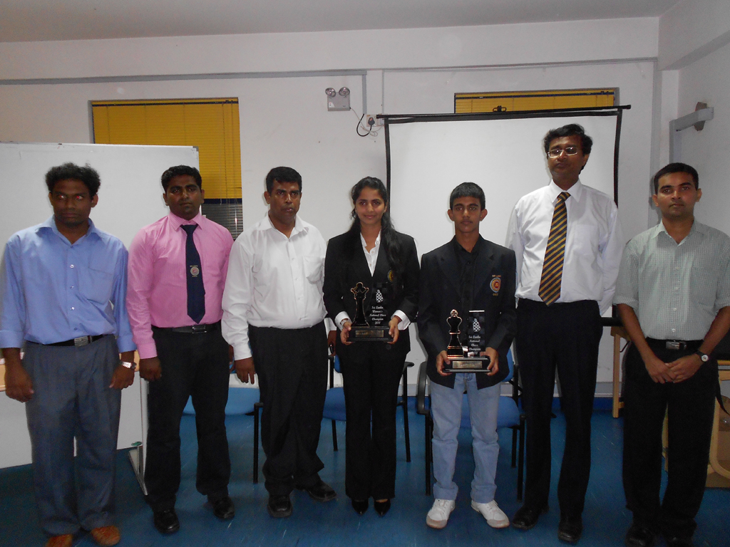
From L-R: Mr. Naditha Amarakoon, (Rating Officer, CFSL)Mr. Jagath Ketalawala (Hony. Secretary,CFSL) By Mr. Luxman Wijesuriya (President,
Zone 3.2, FIDE, General Secretary, Commonwealth Chess Association), Miss Sachini Ranasinghe, Chamika Perera, Mr. Upali Gunasekera (President,
CFSL & Principal, Royal College) & Mr. Erosh Jayasinghe (Tournament Secretary, CFSL)

Luxman Wijesuriya
Vice President - Chess Federation of Sri Lanka
General Secretary, Commonwealth Chess Association
President - Zone 3.2, FIDE

